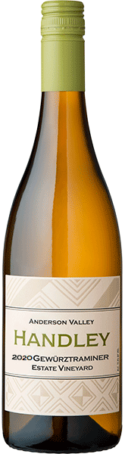

2020 GEWURZTRAMINER
HANDLEY ESTATE VINEAYRD
ANDERSON VALLEY
Our organically farmed, Handley Estate Vineyard planted in 1997 and CCOF certified since 2005, provides the intensely flavored and perfumed fruit for this wine. A prominent nose of rose petals, orange peels, and cardamom. This dry wine is fruity and full on the palate with rich flavors of bosc pears, white peaches, and lychee finishing crisply with hints of ginger and grapefruit pith. Fermented in a combination of stainless steel and large format, neutral wood barrels. The portion fermented in stainless steel provides the intense fruit and spice, while extended lees contact in the barrels contributes weight on the palate and the perception of sweetness.
Cases Produced 282, Alcohol 13.3%. Titratable acidity 5.0 g/L. pH 3.54. RS 0.16%

