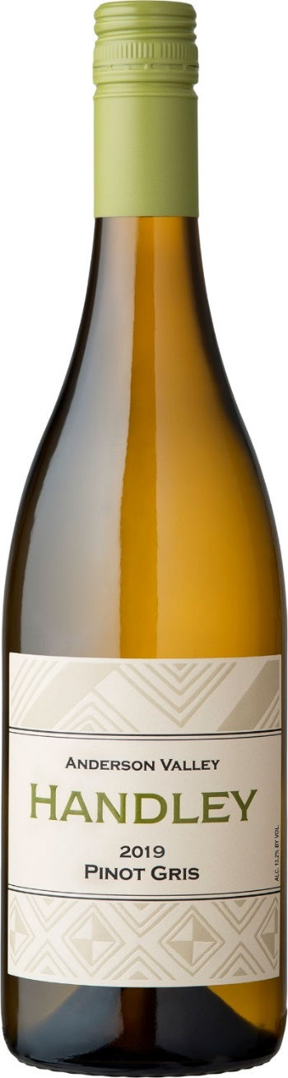

2019
Pinot Gris
Anderson Valley
The fruit for this wine is sourced from Helluva and Romani Vineyards located at opposite ends of Anderson Valley. It is not unusual for these vineyards to be harvested a month apart. Helluva Vineyard provides the tropical and herbal notes while Romani Vineyard provides riper stone fruit characters. Aromas of peaches, lemon blossoms, and thyme. Mouthwatering flavors of guava, pineapple, and lime zest interplay with fleshy nectarine and peach pit with hints of lemongrass on the crisp finish. Fermented in a combination of one third stainless steel tanks and two thirds large format, neutral wood barrels allowing stirring and extended lees contact. Cases produced 1311. Retail: $24.00 Club: $19.20
Alcohol 13.6%, titratable acidity 5.4 g/L, pH 3.34 RS – 0.14%

