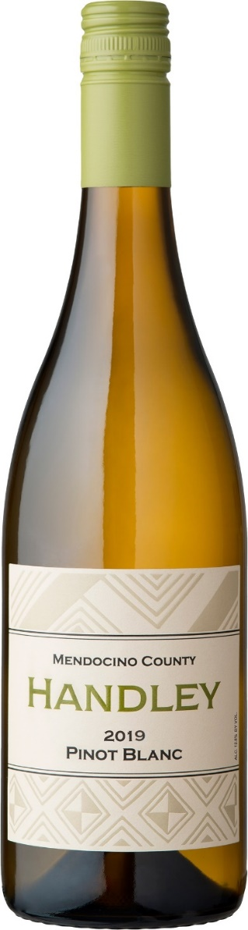

2019
PINOT BLANC
MENDOCINO COUNTY
This Pinot Blanc from the Schrader Vineyard in Ukiah immediately draws you in with its sunny nature and aromas of spring flowers, apricot blossoms and musk melon. This wine was fermented primarily in stainless steel. Near the end of fermentation, it was racked dirty to a traditional oak foudre, and smaller neutral oak barrels. Exposure to small amounts of oxygen and the tannins in the neutral oak helped to clarify and soften the wine. Stirring on the yeast lees adds a creamy texture. It is blessed with juicy peach and pineapple flavors, along with hints of Macadamia nuts. This pinot blanc is round and full on the palate with a tingling of pineapple on finish. Retail Price $24

