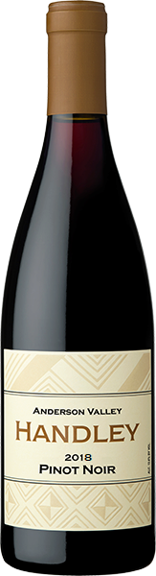

2018
PINOT NOIR
ANDERSON VALLEY
This wine blended from five different vineyards Handley Estate (50%), RSM Estate (19%), Helluva (15%), Lost Creek (9%), and Roderick (7%) embodies the spirit of Anderson Valley. Aromas of warm cherry pie, cola, violets, and a hint of clove on the finish. Round and full on the palate with flavors of red cherries, ripe plum, and notes of cardamom with soft tannins and vibrant acidity to focus the long finish. Aged for 10 months in all French Oak barrels (25% new). Cases: 2685 • Retail: $38 • Club: $30.40
91 Points – Wine Enthusiast
Cases Produced 1977. Alcohol 13.4%. Titratable Acidity 5.6 g/L. pH 3.78.

