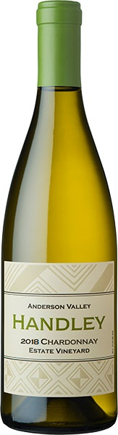

2018
CHARDONNAY
ESTATE VINEYARD ANDERSON VALLEY
Fruit sourced from our organically farmed Handley Estate Vineyard. Soft on the entry, round, and full on the mid palate, crisp on the finish with persistent fruit. Prominent flavors of lime, crisp apples, toasted bread, almonds and hazelnuts. Fermented and aged in all French oak barrels (20% new oak). Only 40% of this wine went through malolactic secondary fermentation.
92 Points – Wine Enthusiast
Cases Produced 1928. Alcohol 13.2. TA 5.1 g/L. pH 3.6.

